Here is a little cheat sheet I use to get the update file on your computer and then save the software file:
_____________________________________

Right now, we have the most recent Software update on http://www.ceecoach.com/ website. When you go to this website you will choose the Support button at the top of the page:

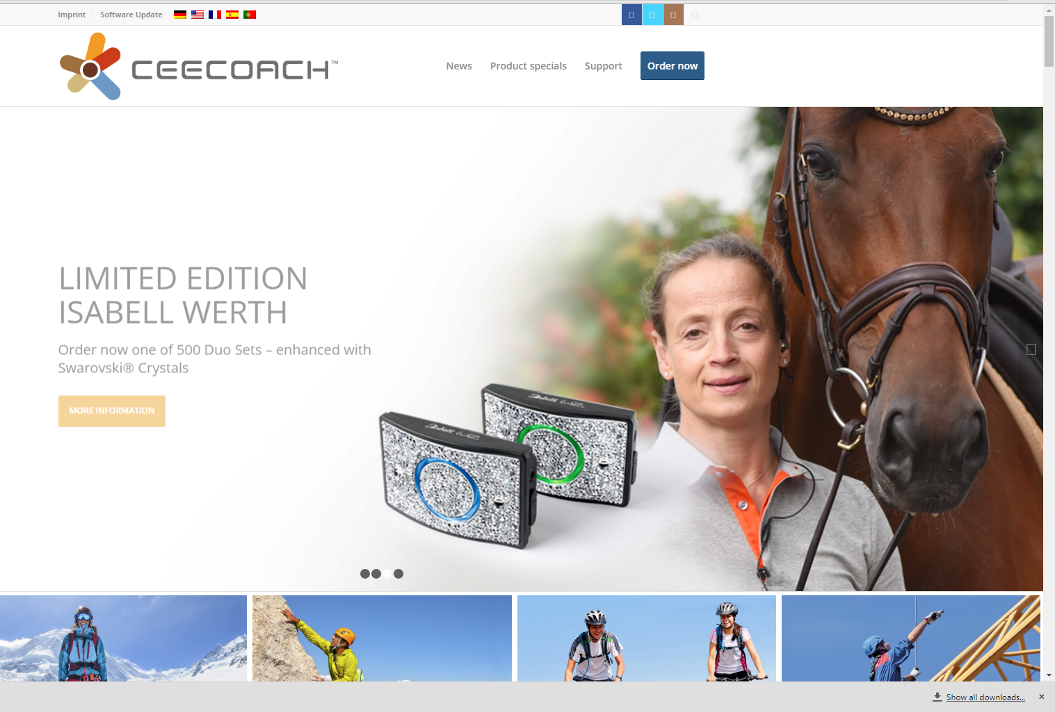
Click,
Then choose Software Update

1st
- Download the “Update File”. This will help you get the new software downloaded to your device. When you click on the download button another screen will come up and you will double click the file CEECOACH_Install_V01.07.exe file for it to download to your computer.

2nd
- Then you will look to your right on the CEECOACH website, it will say “VERSION 01.38/US, please click on the download button and save it to your hard drive (somewhere you will be able to find it). See below:
- You will then go to your windows start button and you should see on the list with CEECOACH on it.
- Choose the files. The screen will bring this up:

- At this point you want to hook up your CEECOACH to your system and reset it. To reset it you will need to:
  - Push all 3 buttons (“+”, “-“ and center button until it blinks with a white light.
- Go to Menu and choose select CEECOACH device….it should be able to show your device at this point.
- -Then go back to the Menu after selecting the device and “Select Update File”. This is why you need to know where you put the software file on your hard drive.
- You will then hit “Update” on the lower right hand of this screen.
- -It will indicate when the update has been completed.
- Then you will turn the units on and re-sync them.

